Name: Majid Ali
CMS ID: 053-25-0017
Course: Java (Lab: 4)

Task No: 1
class Student3{
private String name;
private int id;
private double gpa;

Student3(){
this.id=0;
this.gpa=0.00;
this.name="Unknown";
}

void setName(String name){
this.name=name;
}
void setId(int id){
this.id=id;
}
void setUpdatedGpa(double gpa){
this.gpa=gpa;
}
String getName(){
return name;
}
int getId(){
return id;
}
double getUpdatedGpa(){
return gpa;
}
void display(){
System.out.println("Student Information");
System.out.println("Name: " +getName());
System.out.println("ID: " +getId());
System.out.println("GPA: " +getUpdatedGpa());

}
}
class Main{
public static void main(String args[]){
Student3 s1=new Student3();
Student3 s2=new Student3();
s1.display();
s1.setName("SHeeraz");
s1.setId(1);
s1.setUpdatedGpa(3.90);
s1.display();
s2.setName("Aliyan");
s2.setId(1);
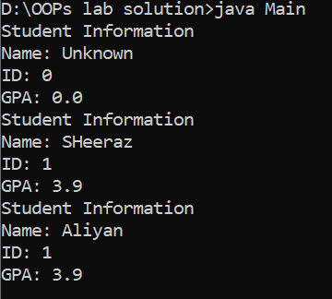
s2.setUpdatedGpa(3.90);
s2.display();
}

}
Task No: 2
class Student3{
private String name;
private int id;
private double gpa;

Student3(){
this.id=0;
this.gpa=0.00;
}
public Student3(String name,int id,double gpa){
this.name=name;
this.id=id;
this.gpa=gpa;
}
void setName(String name){
this.name=name;
}
void setId(int id){
this.id=id;
}
void setUpdatedGpa(double gpa){
this.gpa=gpa;
}
boolean getIsHonour(){
if(gpa>3.5){
return true;
}
else{
return false;
}
}
String getStatus(){
if(gpa>=3.6){
return "Excellence";
}
if(gpa>=3.4 && gpa<3.6){
return "Good";
}
if(gpa>=3 && gpa<3.4){
return "Average";
}
else {
return "Need improvement";
}
}
String getName(){
return name;
}
int getId(){
return id;
}
double getUpdatedGpa(){
return gpa;
}
void display(){
System.out.println("Name: " +getName());
System.out.println("ID: " +getId());
System.out.println("GPA: " +getUpdatedGpa());
System.out.println("is honor " +getIsHonour());
System.out.println("Status " +getStatus());
}
}
class Main{
public static void main(String args[]){
Student3 s1=new Student3();
Student3 s2=new Student3();
s1.setName("SHeeraz");
s1.setId(1);
s1.setUpdatedGpa(3.90);
s1.display();
s2.setName("Aliyan");
s2.setId(1);
s2.setUpdatedGpa(3.90);
s2.display();
}

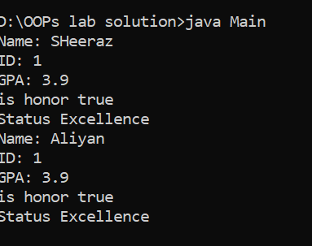

Task No: 3

class NamingDetail{
String name;
int id;
double cgpa;
NamingDetail(String name, int id, double cgpa) {
this.name = name;
this.id = id;
this.cgpa = cgpa;
}
String formatName() {
int spaceIndex = name.indexOf(" ");
String firstName = name.substring(0, spaceIndex);
String lastName = name.substring(spaceIndex + 1);

return lastName.toUpperCase() + ", " + firstName.toUpperCase();
}
String getInitials() {
int spaceIndex = name.indexOf(" ");
char firstInitial = name.substring(0, 1).toUpperCase().charAt(0);
char lastInitial = name.substring(spaceIndex + 1, spaceIndex + 2)
.toUpperCase().charAt(0);

return "" + firstInitial + lastInitial;
}

boolean validateName() {
for (int i = 0; i < name.length(); i++) {
char ch = name.charAt(i);
if (!((ch >= 'A' && ch <= 'Z') ||
(ch >= 'a' && ch <= 'z') ||
ch == ' ')) {
return false;
}
}
return true;
}
String[] getStudentInfoArray() {
String[] info = new String[3];
info[0] = name;
info[1] = String.valueOf(id);
info[2] = String.valueOf(cgpa);
return info;
}
}
class Main {
public static void main(String[] args) {

NamingDetail s = new NamingDetail("Majid Ali", 12345, 3.75);

System.out.println("Formatted Name: " + s.formatName());
System.out.println("Initials: " + s.getInitials());
System.out.println("Valid Name: " + s.validateName());

String[] infoArray = s.getStudentInfoArray();
for (String value : infoArray) {
System.out.println(value);
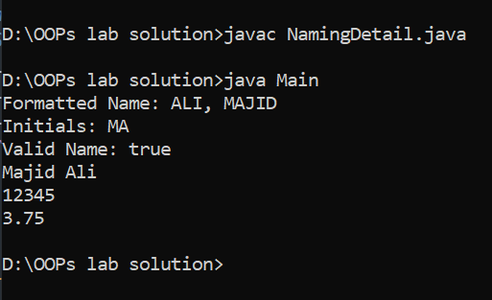
}
}
}

Task No: 4
class NamingDetail {
String name;
int id;
double cgpa;

NamingDetail(String name, int id, double cgpa) {
this.name = name;
this.id = id;
this.cgpa = cgpa;
}

String formatName() {
int spaceIndex = name.indexOf(" ");
String firstName = name.substring(0, spaceIndex);
String lastName = name.substring(spaceIndex + 1);
return lastName.toUpperCase() + ", " + firstName.toUpperCase();
}

String getInitials() {
int spaceIndex = name.indexOf(" ");
char firstInitial = name.substring(0, 1).toUpperCase().charAt(0);
char lastInitial = name.substring(spaceIndex + 1, spaceIndex + 2)
.toUpperCase().charAt(0);
return "" + firstInitial + lastInitial;
}

boolean validateName() {
for (int i = 0; i < name.length(); i++) {
char ch = name.charAt(i);
if (!((ch >= 'A' && ch <= 'Z') ||
(ch >= 'a' && ch <= 'z') ||
ch == ' ')) {
return false;
}
}
return true;
}

String[] getStudentInfoArray() {
String[] info = new String[3];
info[0] = name;
info[1] = String.valueOf(id);
info[2] = String.valueOf(cgpa);
return info;
}

double processGPAs(double[] gpas) {
double highest = gpas[0];

for (double gp : gpas) {

if (gp > 4.0)
break;

if (gp <= 1.0)
continue;

if (gp > highest)
highest = gp;
}
return highest;
}
double AverageG(double[] gpas) {
double sum = 0;
for (int i = 0; i < gpas.length; i++) {
sum += gpas[i];
}
return sum / gpas.length;
}
boolean findGradeInArray(char[] grades, char target) {
for (int i = 0; i < grades.length; i++) {
if (grades[i] == target)
return true;
}
return false;
}

int getGradeArray(char[] grades) {
return grades.length;
}

double[] modifyArray(int[] numbers) {
double[] result = new double[numbers.length];
for (int i = 0; i < numbers.length; i++) {
result[i] = numbers[i] * 2.0;
}
return result;
}
}

class Main {
public static void main(String[] args) {

NamingDetail s = new NamingDetail("Majid Ali", 12345, 3.75);

System.out.println("Formatted Name: " + s.formatName());
System.out.println("Initials: " + s.getInitials());
System.out.println("Valid Name: " + s.validateName());

String[] infoArray = s.getStudentInfoArray();
for (String value : infoArray) {
System.out.println(value);
}

double[] gpas = {3.5, 2.0, 4.1, 3.9};
System.out.println("Highest GPA: " + s.processGPAs(gpas));
System.out.println("Average GPA: " + s.AverageG(gpas));

char[] grades = {'A', 'B', 'C', 'D'};
System.out.println("Grade Found: " + s.findGradeInArray(grades, 'B'));
System.out.println("Total Grades: " + s.getGradeArray(grades));

int[] nums = {2, 4, 6};
double[] doubled = s.modifyArray(nums);

System.out.print("Modified Array: ");
for (double d : doubled) {
System.out.print(d + " ");
}
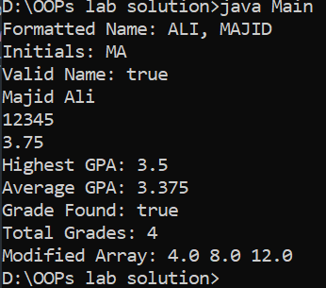
}
}

Task No: 5
class Student4{
String name;
int id;
double cgpa;

Student4(String name, int id, double cgpa) {
this.name = name;
this.id = id;
this.cgpa = cgpa;
}

int calculateTotal(int a, int b) {
return a + b;
}

double calculateTotal(double a, double b) {
return a + b;
}

int calculateTotal(int a, int b, int c) {
return a + b + c;
}

int process2DArray(int[][] matrix) {
int max = matrix[0][0];
for (int i = 0; i < matrix.length; i++) {
for (int j = 0; j < matrix[i].length; j++) {
if (matrix[i][j] > max) {
max = matrix[i][j];
}
}
}
return max;
}

int[][] getStudentGrades2D() {
int[][] grades = {
{85, 90, 88, 92},
{78, 82, 80, 85},
{92, 95, 90, 93}
};
return grades;
}

void displayGradeTable(int[][] grades) {
System.out.println("Grade Table:");
for (int i = 0; i < grades.length; i++) {
System.out.print("Student " + i + ": ");
for (int j = 0; j < grades[i].length; j++) {
System.out.print(grades[i][j] + " ");
}
System.out.println();
}
}

double calculateRowAverage(int[][] grades, int row) {
double sum = 0;
for (int i = 0; i < grades[row].length; i++) {
sum += grades[row][i];
}
return sum / grades[row].length;
}

double calculateColumnAverage(int[][] grades, int col) {
double sum = 0;
for (int i = 0; i < grades.length; i++) {
sum += grades[i][col];
}
return sum / grades.length;
}
}

class Main {
public static void main(String[] args) {
Student4 s1 = new Student4("Majid Ali", 12345, 3.75);

System.out.println("Sum (int): " + s1.calculateTotal(5, 3));
System.out.println("Sum (double): " + s1.calculateTotal(5.5, 3.2));
System.out.println("Sum (3 ints): " + s1.calculateTotal(5, 3, 2));

int[][] matrix = {{1, 2, 3}, {4, 5, 6}, {7, 8, 9}};
int max = s1.process2DArray(matrix);
System.out.println("Max value: " + max);

int[][] grades = s1.getStudentGrades2D();
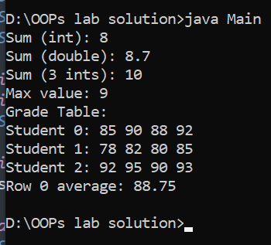
s1.displayGradeTable(grades);

double rowAvg = s1.calculateRowAverage(grades, 0);
System.out.println("Row 0 average: " + rowAvg);
}
}

Task No: 6
class Student4 {
String name;
int id;
double cgpa;

Student4(String name, int id, double cgpa) {
this.name = name;
this.id = id;
this.cgpa = cgpa;
}

int calculateTotal(int a, int b) {
return a + b;
}

double calculateTotal(double a, double b) {
return a + b;
}

int calculateTotal(int a, int b, int c) {
return a + b + c;
}

int process2DArray(int[][] matrix) {
int max = matrix[0][0];
for (int i = 0; i < matrix.length; i++) {
for (int j = 0; j < matrix[i].length; j++) {
if (matrix[i][j] > max) {
max = matrix[i][j];
}
}
}
return max;
}

int[][] getStudentGrades2D() {
return new int[][]{
{85, 90, 88, 92},
{78, 82, 80, 85},
{92, 95, 90, 93}
};
}

void displayGradeTable(int[][] grades) {
System.out.println("Grade Table:");
for (int i = 0; i < grades.length; i++) {
System.out.print("Student " + i + ": ");
for (int j = 0; j < grades[i].length; j++) {
System.out.print(grades[i][j] + " ");
}
System.out.println();
}
}

double calculateRowAverage(int[][] grades, int row) {
double sum = 0;
for (int i = 0; i < grades[row].length; i++) {
sum += grades[row][i];
}
return sum / grades[row].length;
}

double calculateColumnAverage(int[][] grades, int col) {
double sum = 0;
for (int i = 0; i < grades.length; i++) {
sum += grades[i][col];
}
return sum / grades.length;
}

int[][] createUnevenArray() {
int[][] arr = new int[3][];
arr[0] = new int[]{1, 2};
arr[1] = new int[]{3, 4, 5, 6};
arr[2] = new int[]{7, 8, 9};
return arr;
}

void displayUnevenArray(int[][] arr) {
System.out.println("Uneven Array:");
for (int i = 0; i < arr.length; i++) {
System.out.print("Row " + i + ": ");
for (int j = 0; j < arr[i].length; j++) {
System.out.print(arr[i][j] + " ");
}
System.out.println();
}
}

String[] convertTypes() {
int a = 10;
double b = a;
double c = 9.7;
int d = (int) c;
char ch = 'A';
int e = (int) ch;

return new String[]{
"Int to Double: " + b,
"Double to Int: " + d,
"Char to Int: " + e
};
}

String demonstrateTypePromotion() {
byte b = 5;
short s = 10;
int i = 20;
long result1 = b + s + i;

int x = 15;
float y = 5.5f;
double result2 = x + y;

return "Byte+Short+Int (long): " + result1 +
"\nInt+Float (double): " + result2;
}

double processGPAs(double[] gpas) {
double highest = gpas[0];
for (double gp : gpas) {
if (gp > highest) {
highest = gp;
}
}
return highest;
}

String completeStudentReport() {
int[][] grades = getStudentGrades2D();
double avgRow0 = calculateRowAverage(grades, 0);
int max = process2DArray(grades);

String report = "";
report += "Name: " + name + "\n";
report += "ID: " + id + "\n";
report += "CGPA: " + cgpa + "\n";
report += "Max Grade: " + max + "\n";
report += "Row 0 Average: " + avgRow0 + "\n";
report += "Overload Sum (5,5): " + calculateTotal(5,5) + "\n";
return report;
}
}

class Main {
public static void main(String[] args) {
Student4 s1 = new Student4("John Doe", 12345, 3.75);
Student4 s2 = new Student4("Jane Smith", 12346, 3.90);

System.out.println("=== Student 1 ===");
System.out.println(s1.completeStudentReport());

System.out.println("\n=== Student 2 ===");
System.out.println(s2.completeStudentReport());

int[][] uneven = s1.createUnevenArray();
s1.displayUnevenArray(uneven);

String[] conversions = s1.convertTypes();
for (String conv : conversions) {
System.out.println(conv);
}

String promotion = s1.demonstrateTypePromotion();
System.out.println(promotion);

double[] gpas = {3.5, 3.8, 2.9, 3.95};
double highest = s1.processGPAs(gpas);
System.out.println("Highest GPA from array: " + highest);

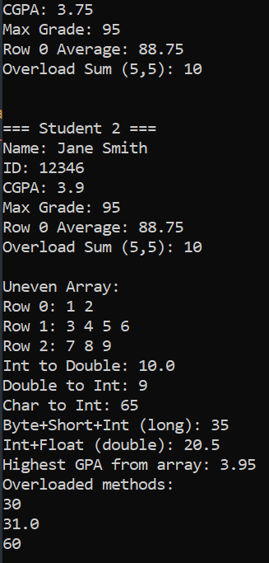
System.out.println("Overloaded methods:");
System.out.println(s1.calculateTotal(10, 20));
System.out.println(s1.calculateTotal(10.5, 20.5));
System.out.println(s1.calculateTotal(10, 20, 30));
}
}

